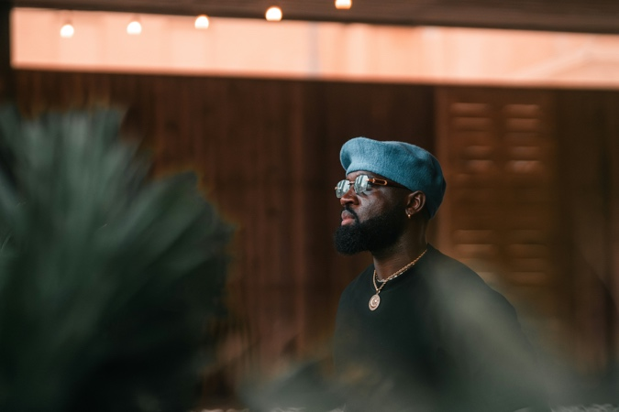

Discussion Name and module number ⁽⁾ | Kick-off MBWC-0110
Desired outcome for module | Coaching process set in motion
Content | Setting up the context in which the person is operating and initial outcomes

Introduction (Define whether video, recorded ppt, text or mixture)

Detailed questions for discussion

- What do you want to get out of going through this coaching process?
- What caused you to decide to take this coaching process?
- Where would you like your focus to be based mainly on work and career or private and social life.
- What are the issues that you want to ensure get addressed and that you get some form of clarity around?
- What, if any, are some of the problems or challenges that you're facing today that you'd like to be resolved?
- Why is this process important to you right now?
- Which mode by default – audio/video or text – for modules where it might be easier one way of another
- Are there any other issues that seemed to be relevant to this process as you move forward?

Brain-wise impact

Reference information (Define whether video, recorded ppt, text or mixture)

- A little bit of background
- Read me first
- Choice of doing this on your own vs. using a coach.
- Description of why this type of process can be useful
- FAQ’s

AI contribution

- Upfront
- During Ask questions and record answers
- At end Provide the initial part of the report which will be a summary for this person of:
  - The outcomes they are looking for
  - Their contextual issues
  - The specific issues they wish to have addressed
  - The problems they are facing today

Additional components

Photo by Hameen Reynolds on Unsplash

